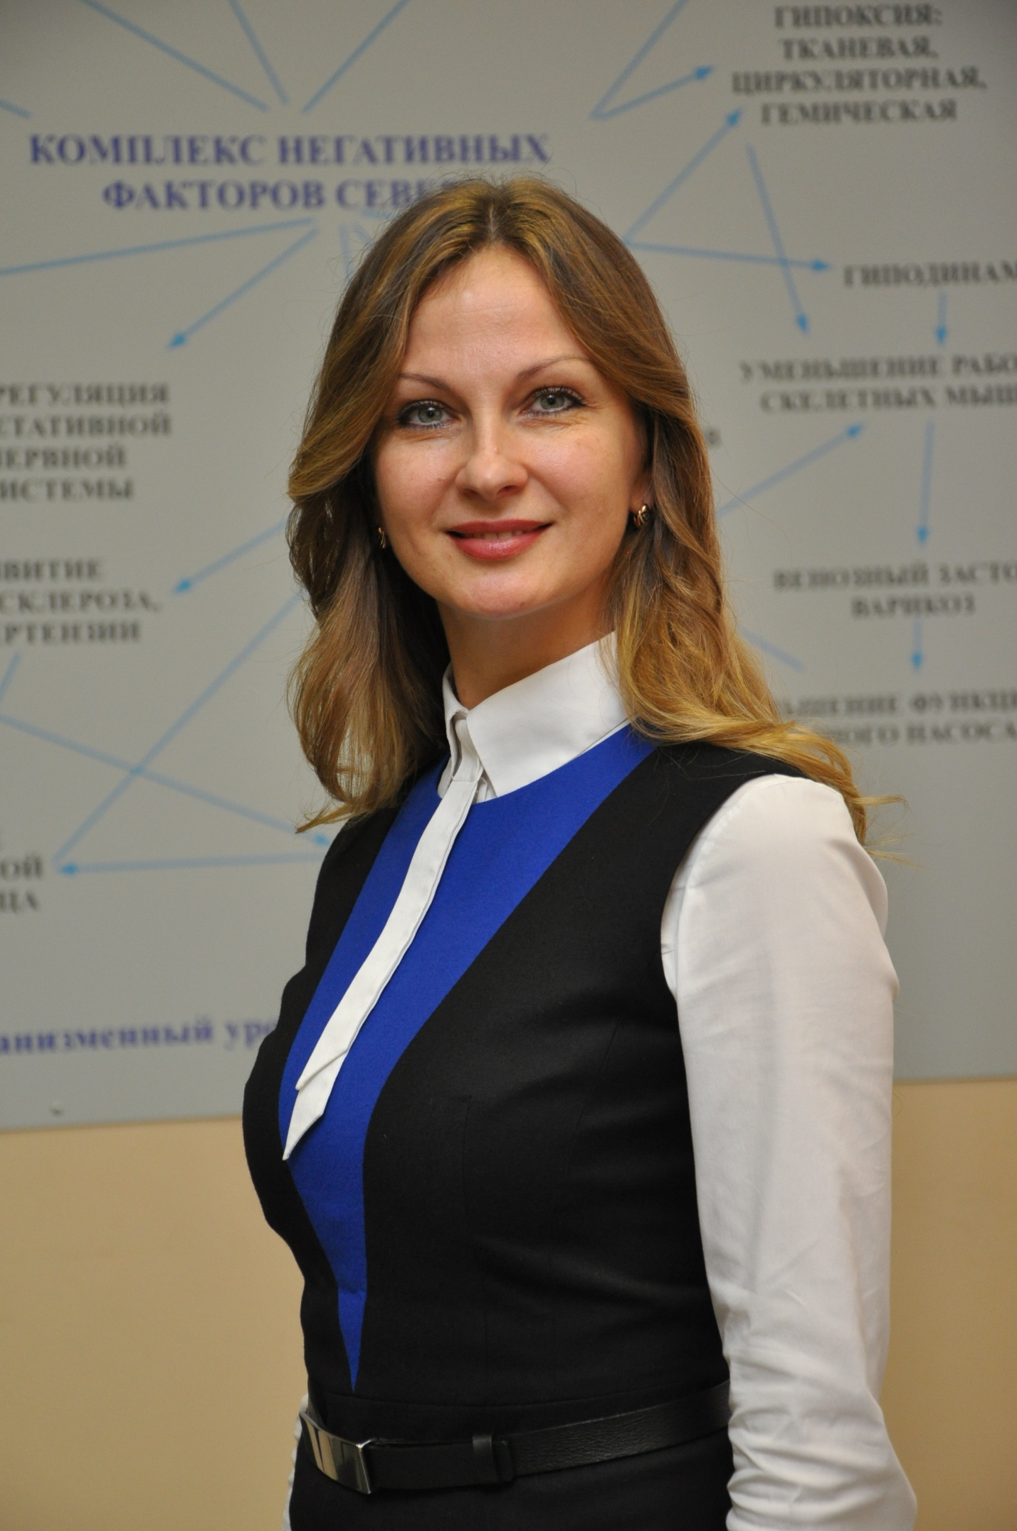

**Olga Popova**

- Doctor of Medical Sciences, Professor of the Department of Hygiene and Medical Ecology of the Northern State Medical University

1997 - graduated from Murmansk Medical College with honors

2001 graduated from the Northern State Medical University with honors.

Took postgraduate course and in 2002, passed PhD. defense on the topic: "The functional state of external respiration in children of high school age, residents of the European North of Russia." In 2009, she defended Doctoral Thesis at the Peoples’ Friendship University of Russia on the topic: “Character of adaptive response of external respiration in young people of working age, residents of the European North”. From March 2002 to October 2007 headed the Scientific -Organizational Section of NSMU. From 2013 to the present, she has been working as a Professor of the Department of Hygiene and Medical Ecology of NSMU.

In total, more than 150 scientific papers have been published, including 6 monographs (co-authored), 3 patents for invention have been obtained (co-authored).

Received credits from the Head of the Arkhangelsk Region Administration and the Administration of NSMU for academic credentials, recipient of Prize named after N.M. Amosov (2002). In 2013, she was awarded the winner’s diploma of the XI regional contest “Book of the Year 2012” in the category “The Best Scientific Edition” for the monograph “External Respiration of a Person in the European North” (co-authored).

Research interests: respiratory physiology, physiology and occupational hygiene.